Content
S.NO | Title | Page Number
1 | Introduction | 2
2 | Requirement Specification | 3
3 | Project Overview | 4
4 | Project Workflow | 7
5 | Source Codes | 10
6 | Screenshots | 12
7 | Dataset and Data Sources | 15
8 | Conclusion | 16

Introduction

The Health AI Suite is a healthcare analytics project that uses machine learning and deep learning techniques to analyze patient-related data and generate meaningful insights. The goal of this project is to support clinical decision-making through early disease detection, estimation of hospital length of stay, grouping of similar patients, mining of medical co-occurrence patterns, analysis of medical images, modeling patient health trends over time, understanding patient feedback.

The system is built using synthetic and publicly available healthcare data, ensuring data privacy and ethical compliance. By combining data preprocessing, model development, evaluation, and deployment through interactive dashboards and APIs, this project demonstrates how AI can be applied to solve real-world healthcare problems in a practical and scalable manner.

The Health AI Suite is designed as a modular system where each model focuses on a specific healthcare task while working as part of a single pipeline. It combines machine learning and deep learning techniques to handle different types of healthcare data such as tabular records, medical images, time-series data, and patient feedback. This approach helps in generating useful predictions and insights that can assist doctors and healthcare teams in day-to-day decision-making. By integrating all components into one platform, the project shows how AI-based solutions can be practically applied in real healthcare scenarios.
Requirement Specification
Hardware Requirements
- 64-bit system (Windows / macOS)
- Minimum 8 GB RAM (4 GB minimum for basic execution)
- Minimum 10 GB free disk space
Software Requirements
- Operating System: Windows 10/11 or macOS
- Python 3.8 or above
- Jupyter Notebook / JupyterLab
- Visual Studio Code or any Python IDE
- Libraries: NumPy, Pandas, Scikit-learn, TensorFlow / Keras, PyTorch (optional)
- FastAPI
- Streamlit

Existing System
In the existing healthcare system, most clinical data analysis and decision-making processes rely on manual evaluation or basic rule-based systems. Patient records, medical reports, and feedback are often reviewed individually, making it difficult to extract meaningful insights from large volumes of data. This approach increases the time required for diagnosis, reporting, and decision-making, while also limiting the ability to identify patterns or predict future health outcomes.
Since the system lacks automation and advanced analytics, it is challenging to track patient trends, group similar patients, or provide timely predictive insights. Manual handling of healthcare data also increases the chances of errors and makes it difficult to manage historical records efficiently. Therefore, an automated and intelligent system is required to improve accuracy, efficiency, and scalability in healthcare data analysis.
Health AI Suite — Intelligent Analytics for Patient Care

1. Project Objective
Health AI Suite is an end-to-end AI/ML system designed to analyze heterogeneous healthcare data—including structured EHR data, medical images, time-series vitals, and patient feedback—to support clinical decision-making, patient monitoring, and hospital operations.
The goal of this project is not to rely on real patient data, but to demonstrate system design, Modeling choices, preprocessing rigor, and deployment readiness using synthetic and publicly available datasets, as permitted in healthcare AI workflows.

2. Problem Statement
Healthcare systems generate diverse data streams that are often analyzed in isolation. This project addresses the challenge of integrating multiple AI paradigms to:
- Predict patient risk categories (classification)
- Estimate hospital length of stay (regression)
- Identify patient cohorts with similar clinical profiles (clustering)
- Detect medical patterns and associations
- Analyze medical images for diagnostic support
- Monitor patient deterioration using time-series modelling
- Extract sentiment from patient feedback
By combining traditional machine learning, deep learning, and NLP models into a unified system, Health AI Suite demonstrates how AI can enhance clinical insight, operational efficiency, and patient engagement.

3. System Architecture Overview
The system follows a modular, service-oriented architecture:
- Data Layer
Synthetic and publicly available datasets (tabular, image, text, time-series)
- Modeling Layer
Independent ML/DL models trained per task:
  - Classification, regression, clustering
  - CNN for imaging
  - LSTM for time-series
  - CNN/LSTM for sentiment analysis
- Inference Layer (Fast API)
  - Centralized REST API
  - Task-specific endpoints
  - Consistent preprocessing aligned with training
- Presentation Layer (Streamlit)
  - Interactive dashboards
  - Real-time monitoring simulation
  - Visualization of predictions and probabilities
This separation ensures reproducibility, scalability, and maintainability.

4. Implemented Modules (Scope Alignment)
The project implements multiple modules from the problem specification, exceeding the mandatory two-module requirement and demonstrating advanced initiative.
Machine Learning Modules
- Risk Stratification (Classification)
Predicts patient risk levels using demographic and laboratory features.
- Length of Stay Prediction (Regression)
Estimates hospitalization duration based on clinical and diagnostic indicators.
- Patient Segmentation (Clustering)
Groups patients into clinically interpretable cohorts using K-Means clustering.
- Medical Associations (Association Rules)
Discovers co-occurrence patterns among diseases and clinical conditions.
Deep Learning Modules
- Imaging Diagnosis (CNN)
Analyzes chest images to support disease detection.
- Sequence Modeling (LSTM)
Models time-series vital signs to detect early signs of patient deterioration.
- Sentiment Analysis (Deep Learning NLP)
Classifies patient feedback as positive or negative to support quality assurance.

5. Data Strategy & Ethics
- No real patient-identifiable data was used.
- Data sources include:
  - Synthetic tabular and time-series data
  - Public medical image datasets
  - Publicly available patient feedback text
- All datasets are anonymized, simulated, or open, complying with ethical AI and healthcare data guidelines.
The project explicitly prioritizes methodology and system design over data volume, reflecting real-world healthcare AI constraints.

6. Deployment & Integration
- Fast API is used to expose trained models as RESTful endpoints.
- Streamlit provides an interactive dashboard for clinicians and users.
- Preprocessing at inference time strictly mirrors training pipelines, ensuring training–inference parity.
- The system is designed to be containerizable and extensible for future MLOps integration.
Project Workflow
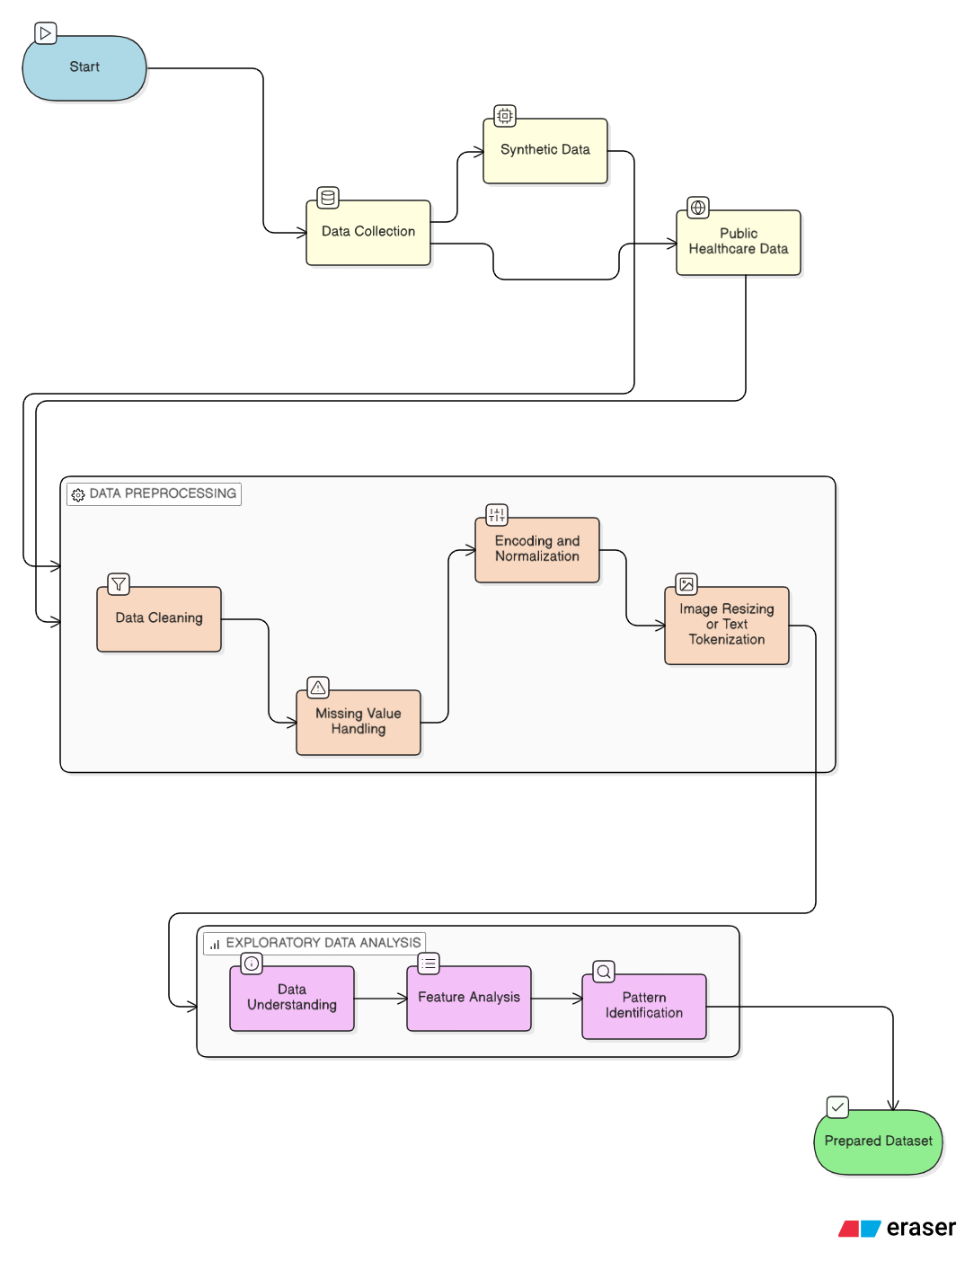

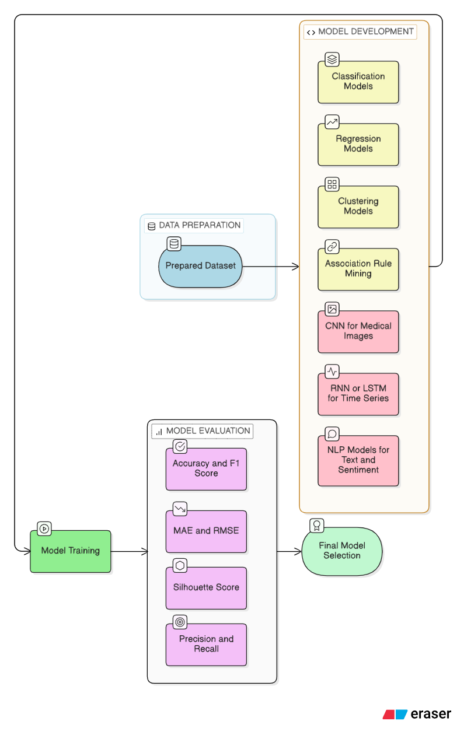

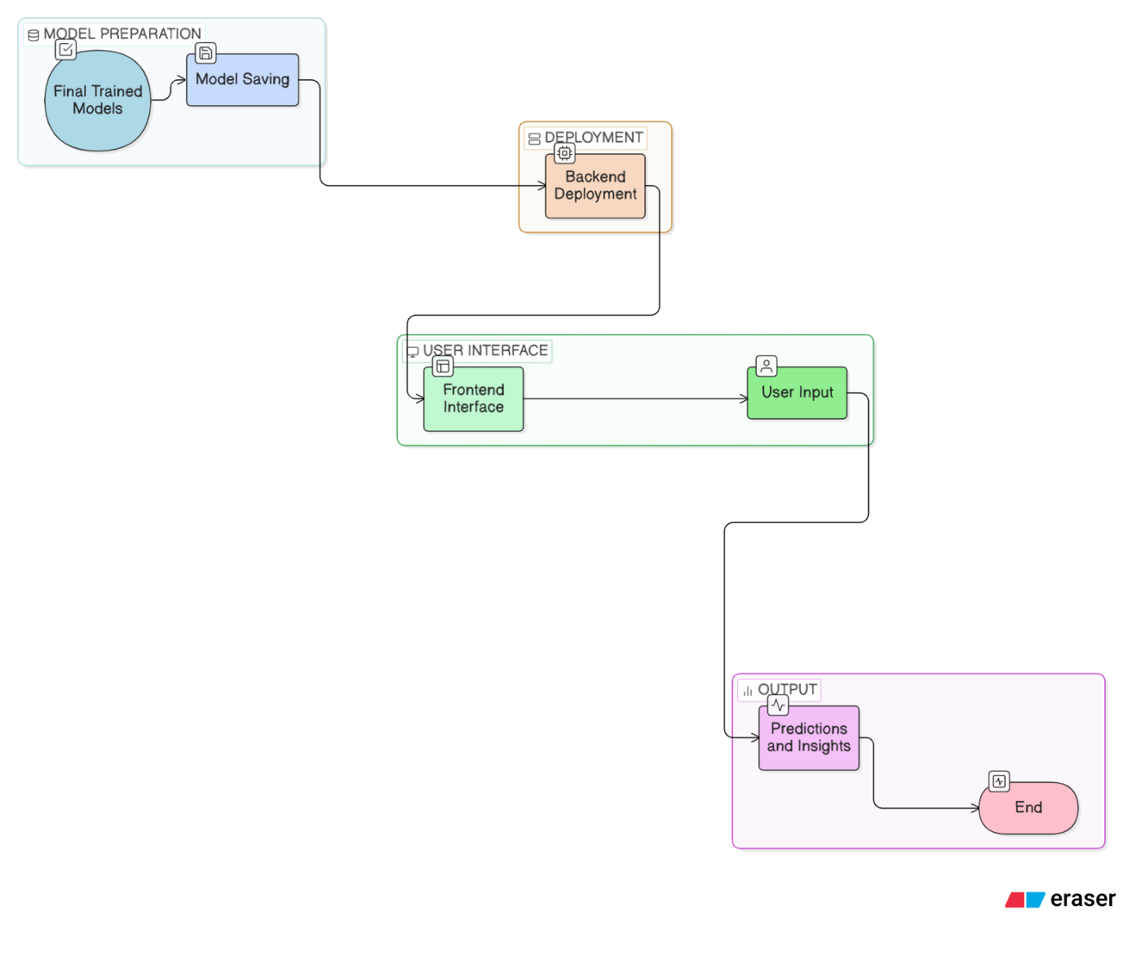

Source Codes

Data Preprocessing and Model Development

Module | Notebook (HTML)
Data Cleaning
Risk Stratification
Length of Stay Prediction
Patient Segmentation
Medical Associations
Imaging Diagnosis (CNN)
Sequence Modeling
Sentiment Analysis

Model deployment

Module | Notebook (HTML)
Streamlit
app.py
Fast API
main.py
loaders.py
Infrence.py

Screenshorts

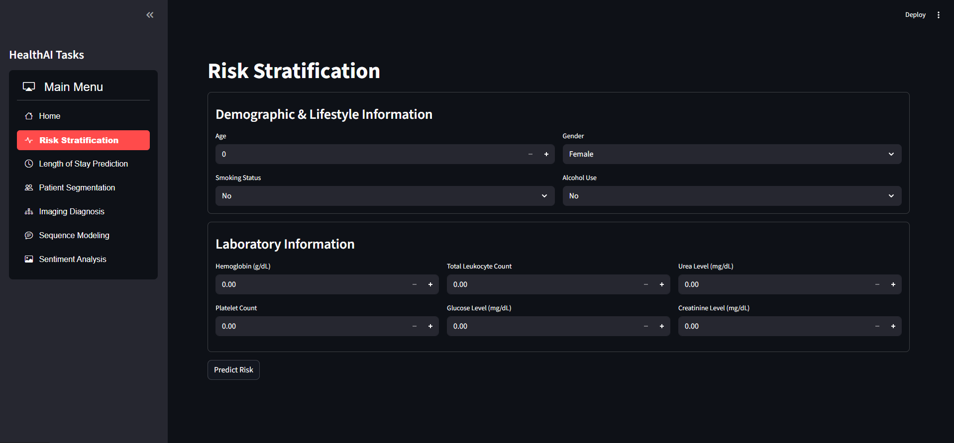

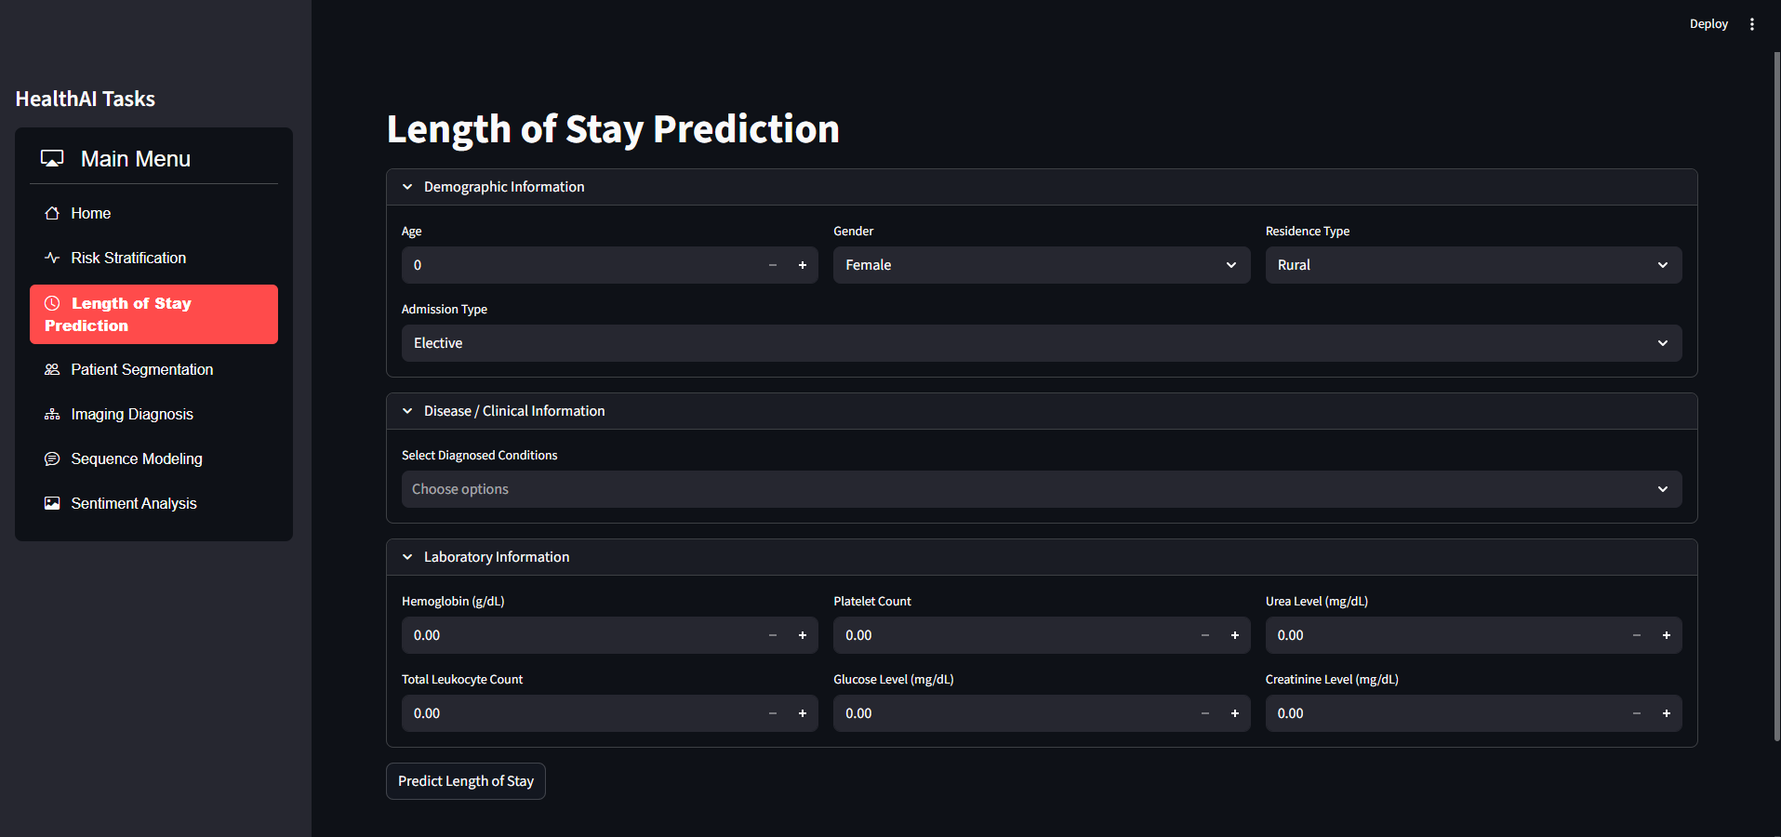

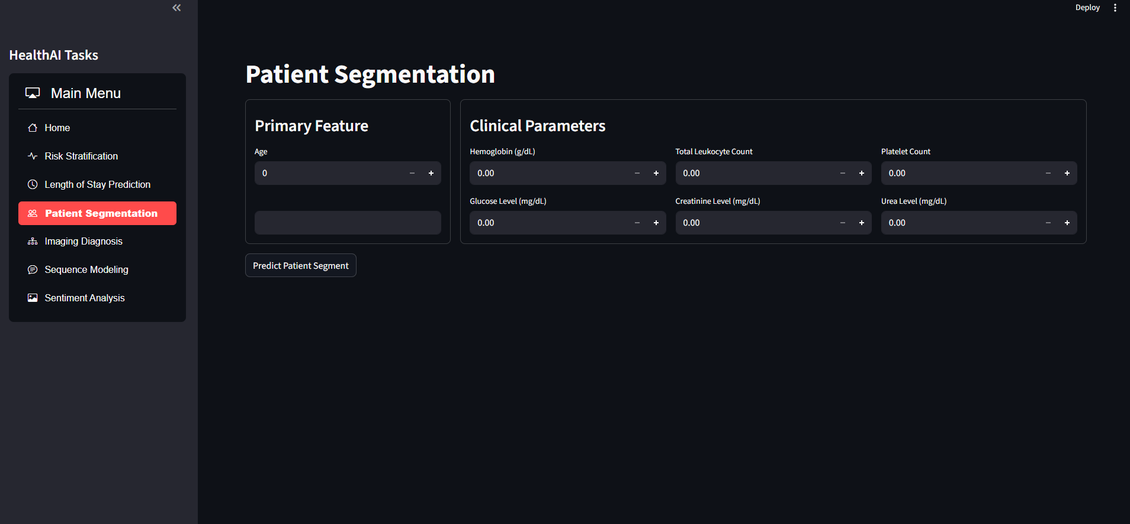
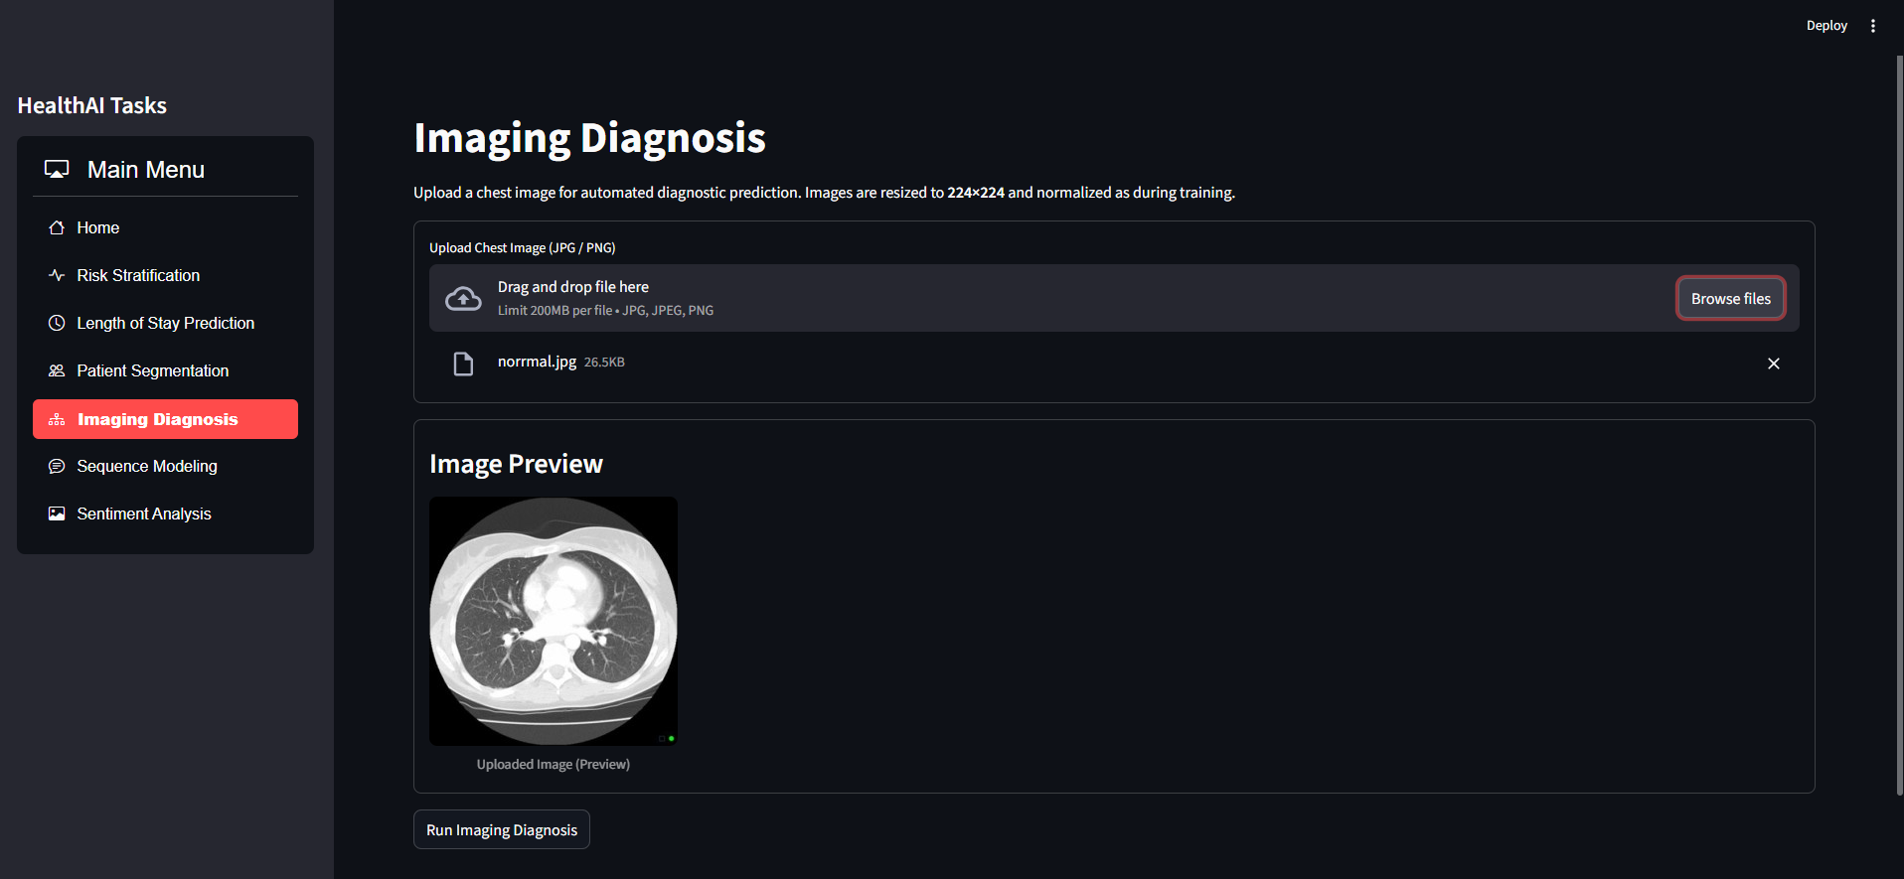

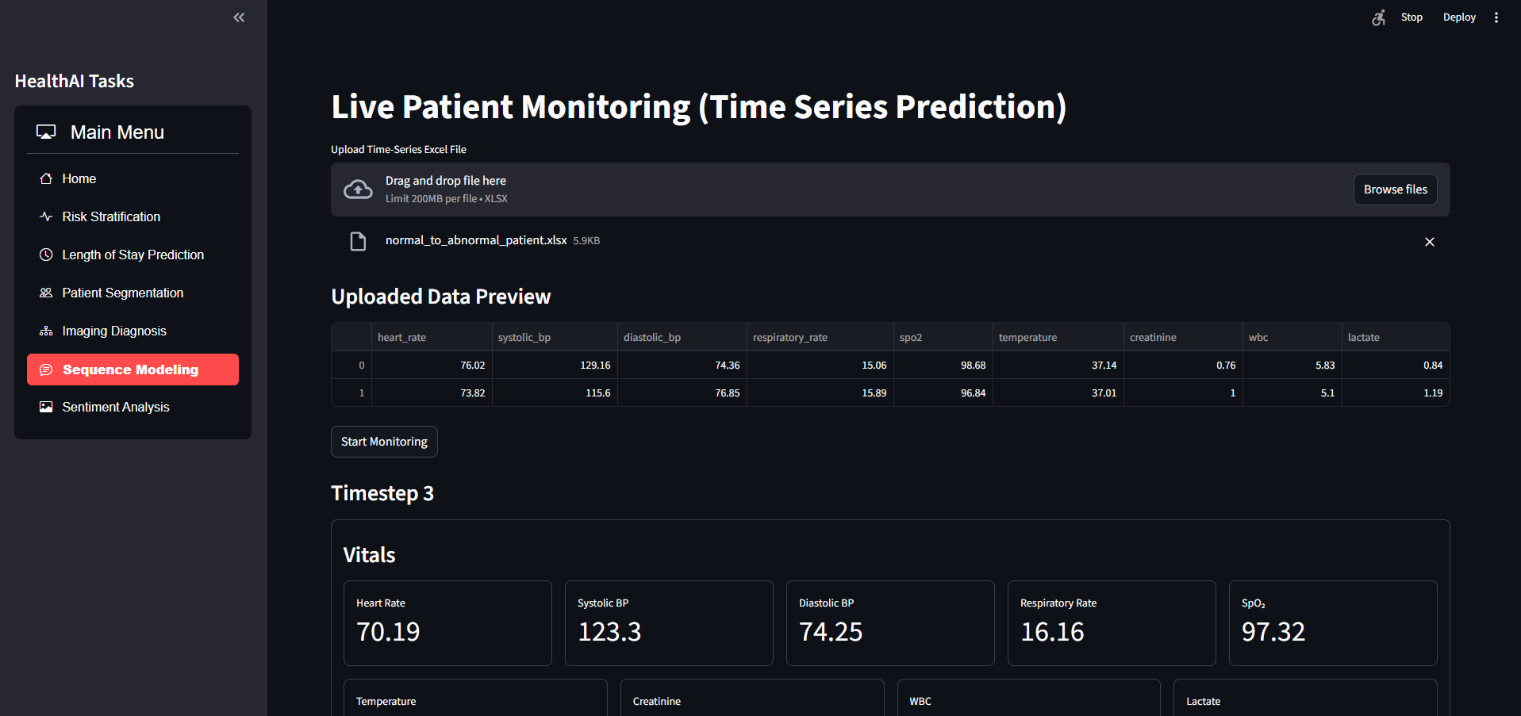
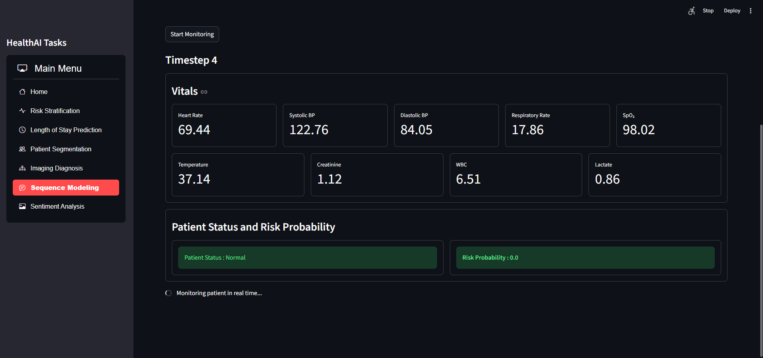
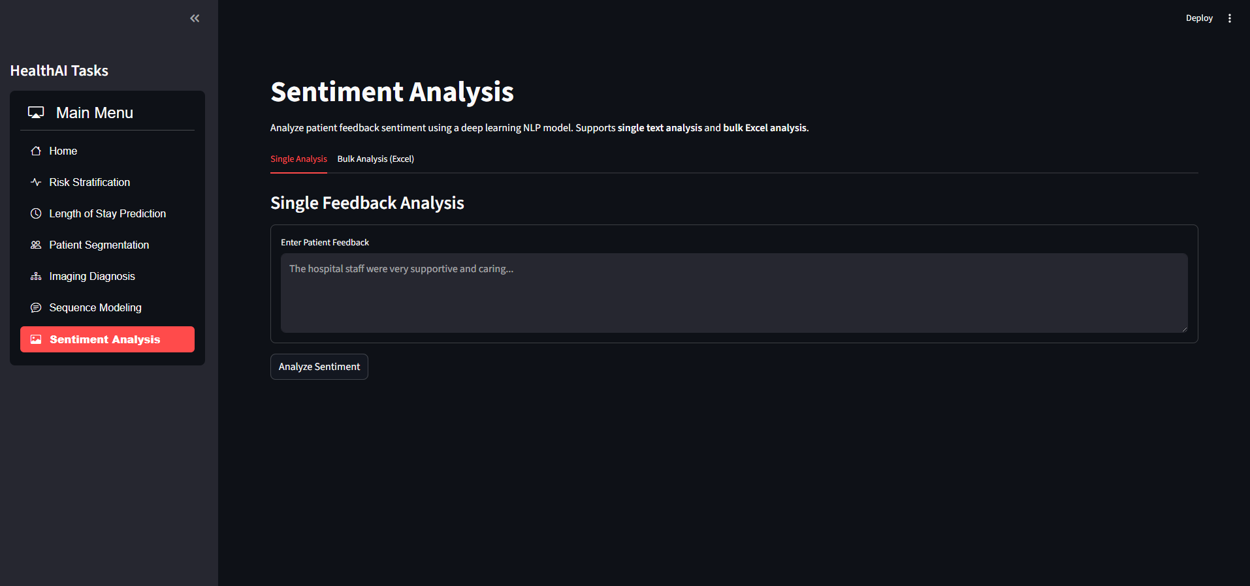

Dataset and Data Sources

Datasets Used in the Project
Machine Learning (ML) Tasks
Tasks Covered:
- Risk Stratification
- Length of Stay Prediction
- Patient Segmentation
- Medical Associations
Dataset Name: Hospital Admissions Data
Platform: Kaggle
Dataset Link: https://www.kaggle.com/datasets/ashishsahani/hospital-admissions-data

Deep Learning (DL) Tasks
Task Covered:
- Imaging Diagnostics
Dataset Name: Chest CT-Scan Images Dataset
Platform: Kaggle
Dataset Link: https://www.kaggle.com/datasets/mohamedhanyyy/chest-ctscan-images

Sequence Modeling
Dataset Description:
- Synthetically generated time-series dataset created for experimental and modeling purposes.

Sentiment Analysis
Dataset Name: Hospital Reviews Dataset
Platform: Kaggle
Dataset Link: https://www.kaggle.com/datasets/junaid6731/hospital-reviews-dataset

Conclusion

The HealthAI Prediction Suite successfully demonstrates the application of machine learning and deep learning techniques in healthcare data analysis. By integrating multiple predictive modules such as risk stratification, length of stay prediction, patient segmentation, imaging diagnosis, time-series monitoring, and sentiment analysis, the system provides a unified platform for healthcare analytics.
The project reduces manual effort, improves analytical accuracy, and offers an interactive interface for data-driven decision support. Overall, the HealthAI system highlights the potential of artificial intelligence in enhancing healthcare insights and serves as a strong foundation for future improvements and real-world applications.

